**13.WRITE THE C PROGRAM TO CALCLATE THE SUM OF ELEMENTS IN AN ARRAY.**

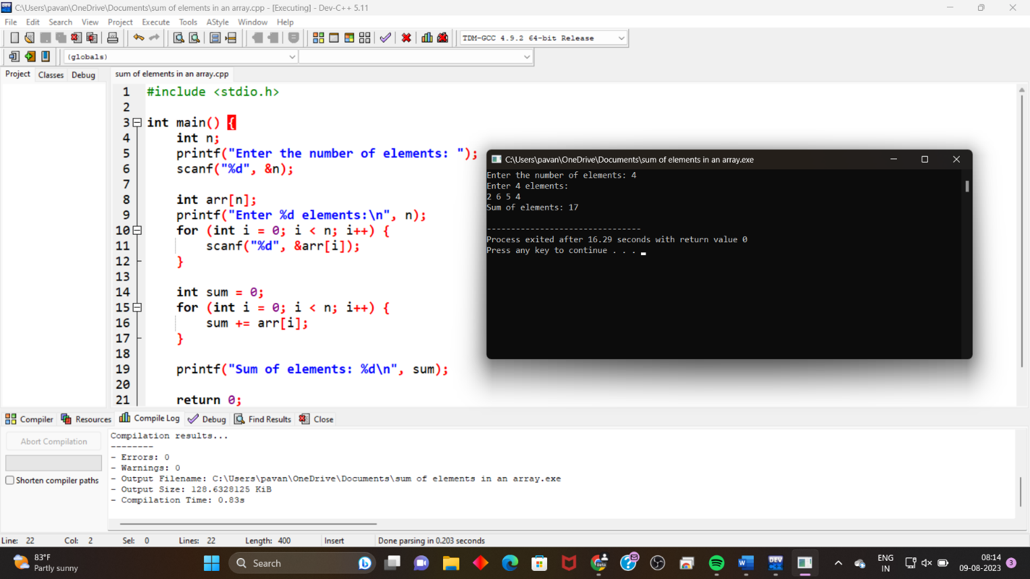

**14.WRITE C PROGRAM TO MERGE TWO ARRAYS .**

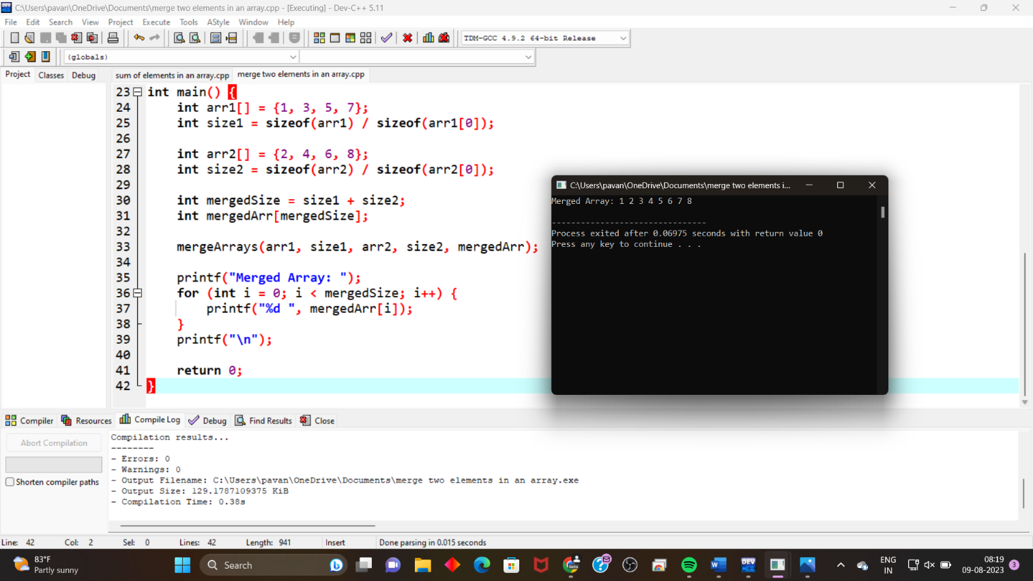

**15. WRITE THE C PROGRAM TO PERFORM INSERTION, DELETION IN THE MIDDLE IN AN ARRAY.**

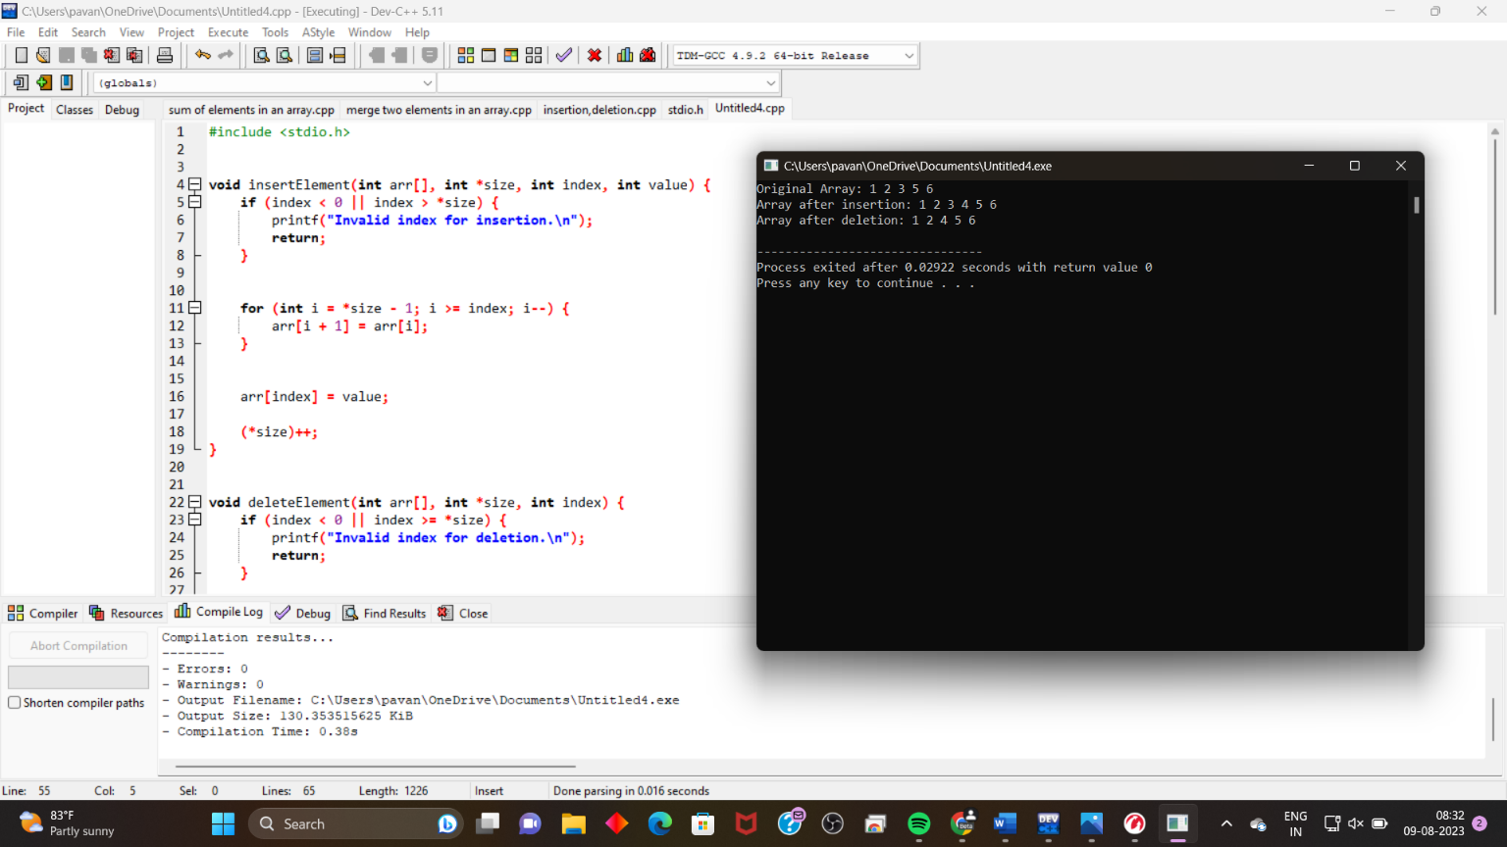

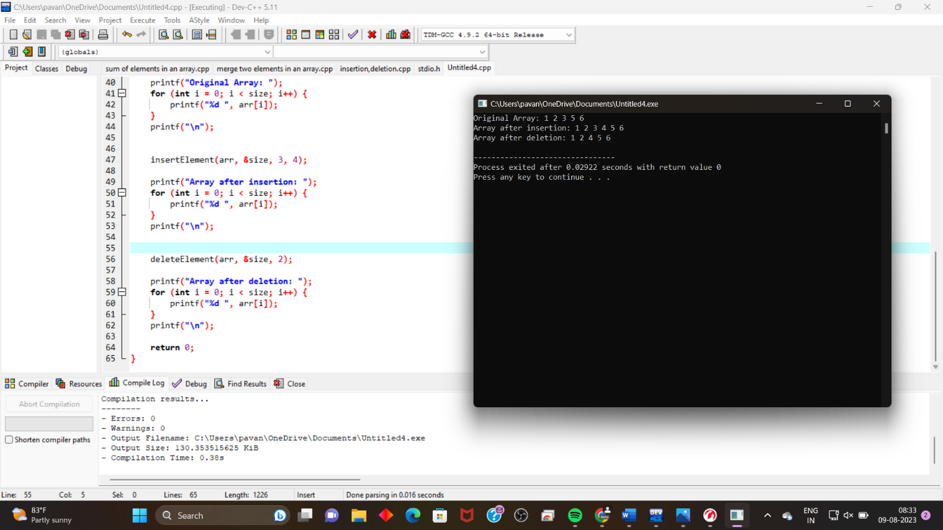

**16. WRITE THE C PROGRAM TO REVERSE A STRING .**

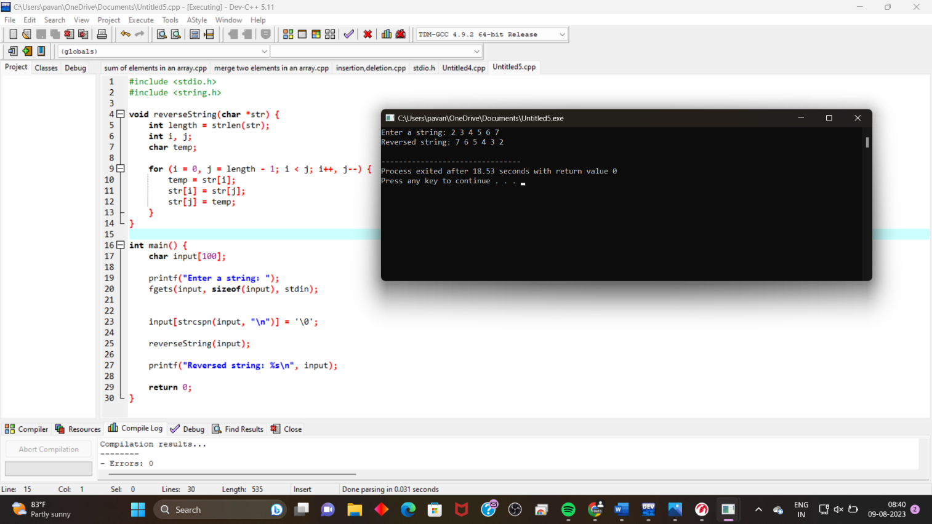

**17.WRITE THE C PROGRAM TO CHECK GIVEN STRING IS PALINDROME OR NOT.**

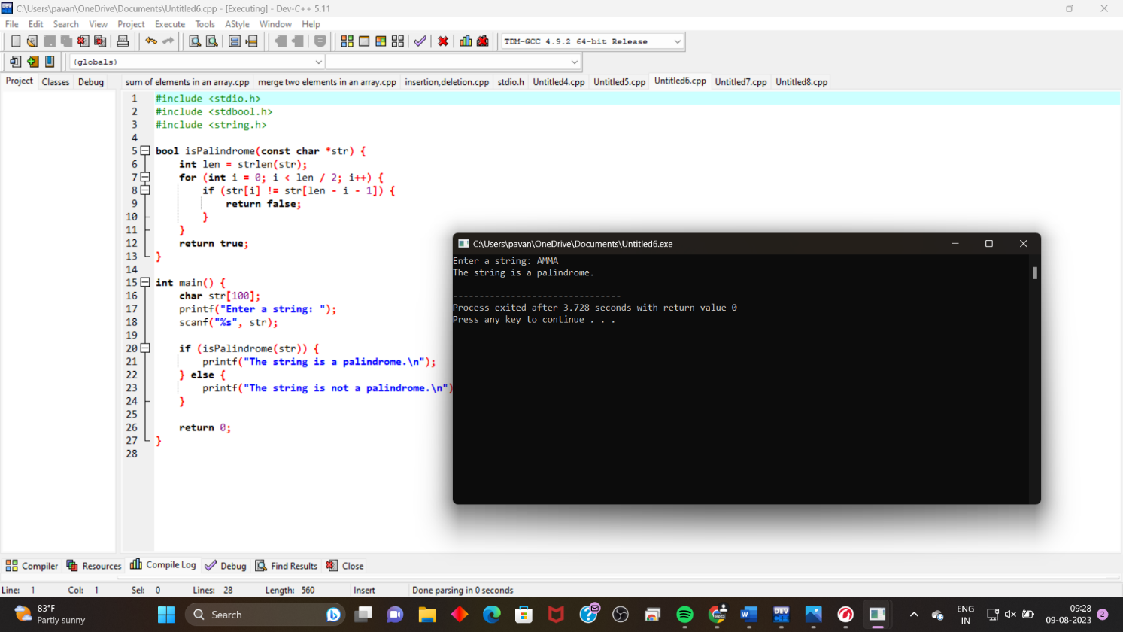

**18. WRITE THE C PROGRAME TO SEARCH A PARTICULAR CHARACTER IN A STRING.**

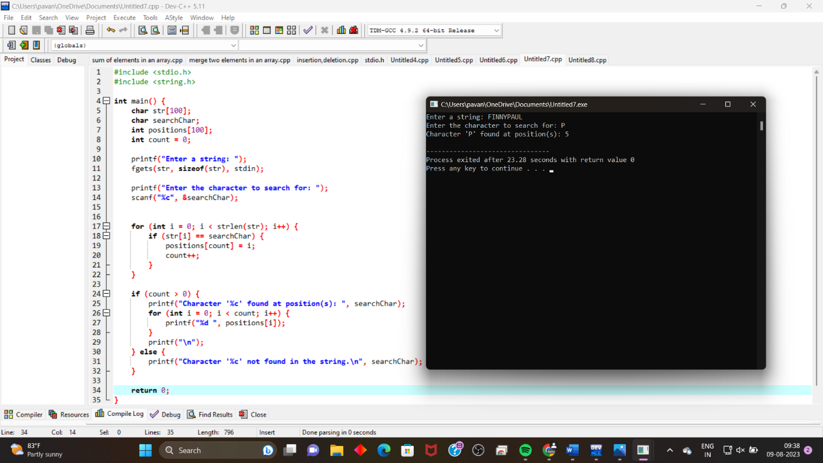

**19. WRITE THE C PROGRAM TO COUNT NUMBER OF TIMES A,E,I,O,U PRESENT IN A GIVEN STRING.**

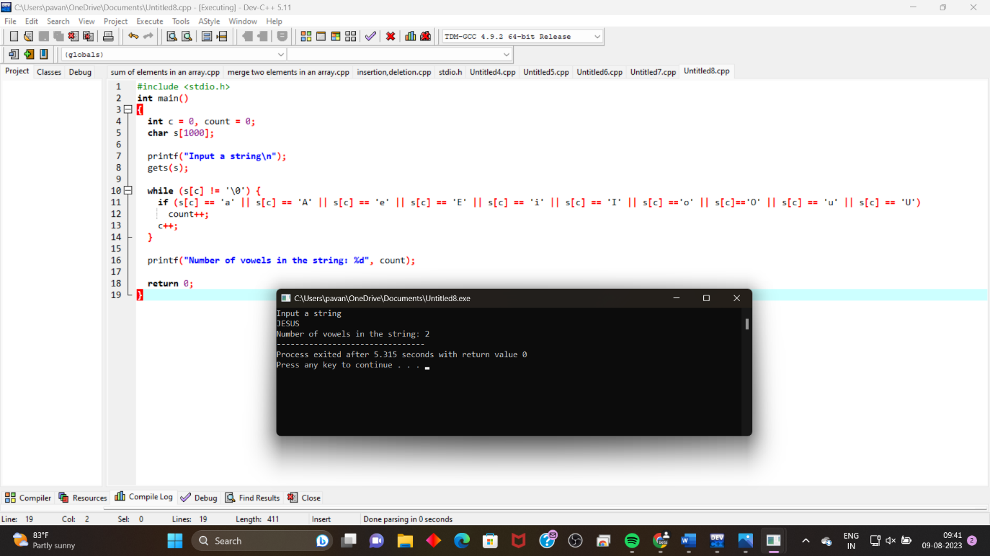

**20. WRITE THE C PROGRAM TO PERFORM MATRIX MULTIPLICATION.**

